**A**

**Sample SRS**

**For**

***https://www.magentomobileshop.com***

**Based**

**On**

**Creating your online store application**

**Through**

**Magento Mobile App Builder**

**Home page**

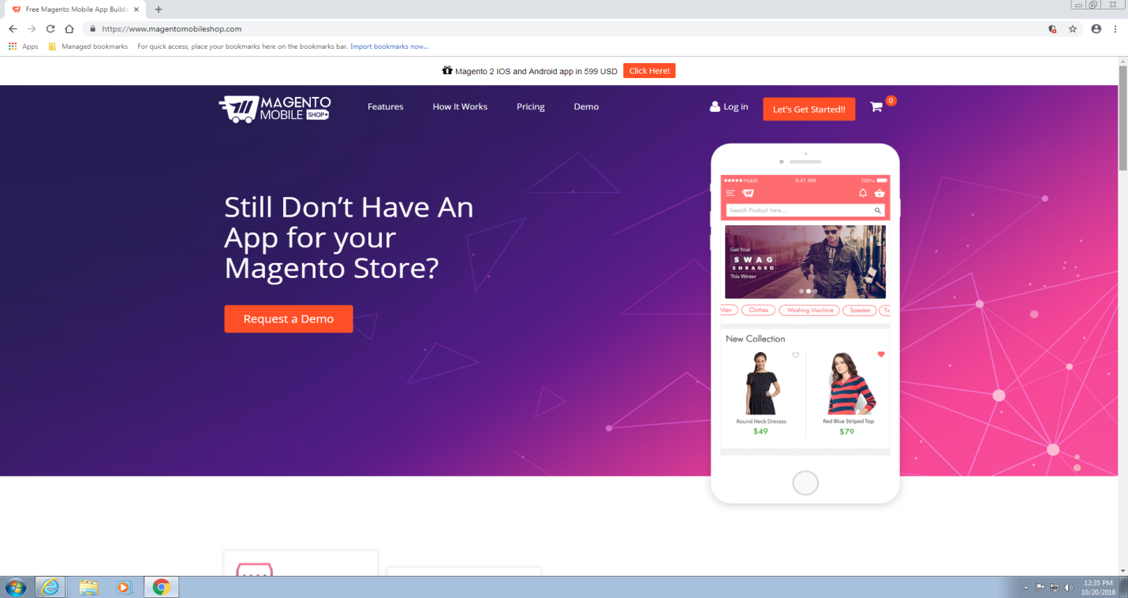

* This is the Home-page of [**https://www.magentomobileshop.com/demo/**](https://www.magentomobileshop.com/demo/)
* It has several hyperlinks present in it.
  + Features
  + How it Works
  + Pricing
  + Demo
  + Let’s Get Started!!
  + Log In
* It has a brief info about the company and what it delivers.

**Features Page**

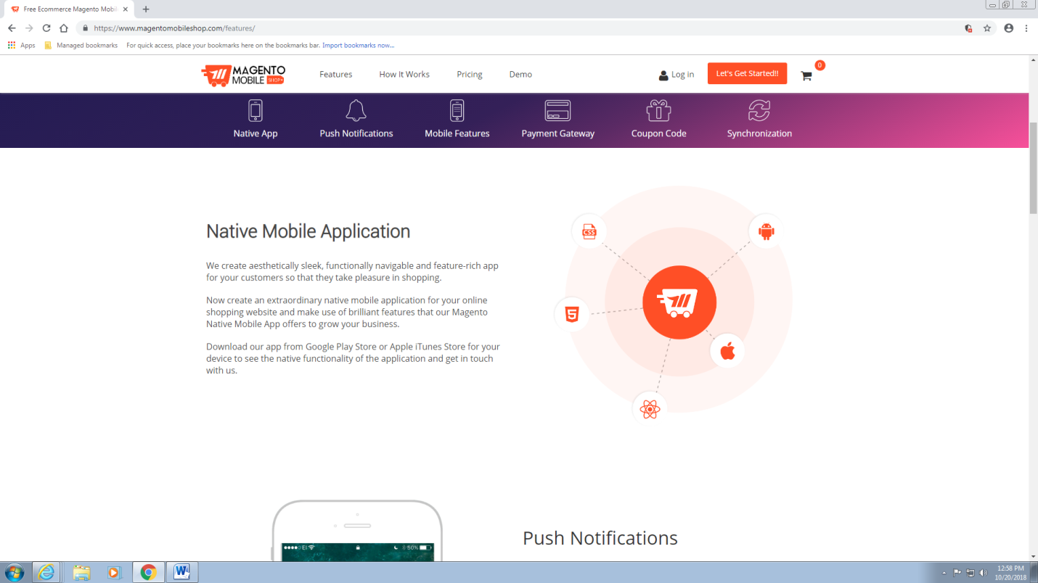

The Features page briefly describes all the features of the **Magento Mobile Shop** website.

It has several features like

* Native Mobile Application
* Push Notifications
* Mobile Features
* Payment Gateways
* Coupon Codes
* Live Synchronization

**How** **It** **Works Page**

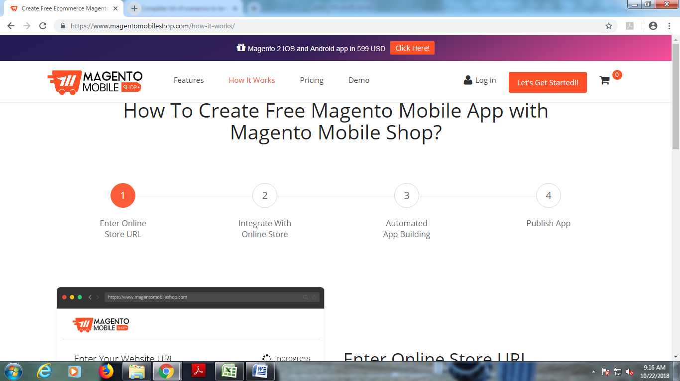

This page gives a brief info about how to create Free Magento Mobile App with Magento Mobile Shop.

* Step by Step process is given with the snapshots to make user understand the steps easily.
* A video is also given to make more easier to understand how it works.

**Pricing Page**

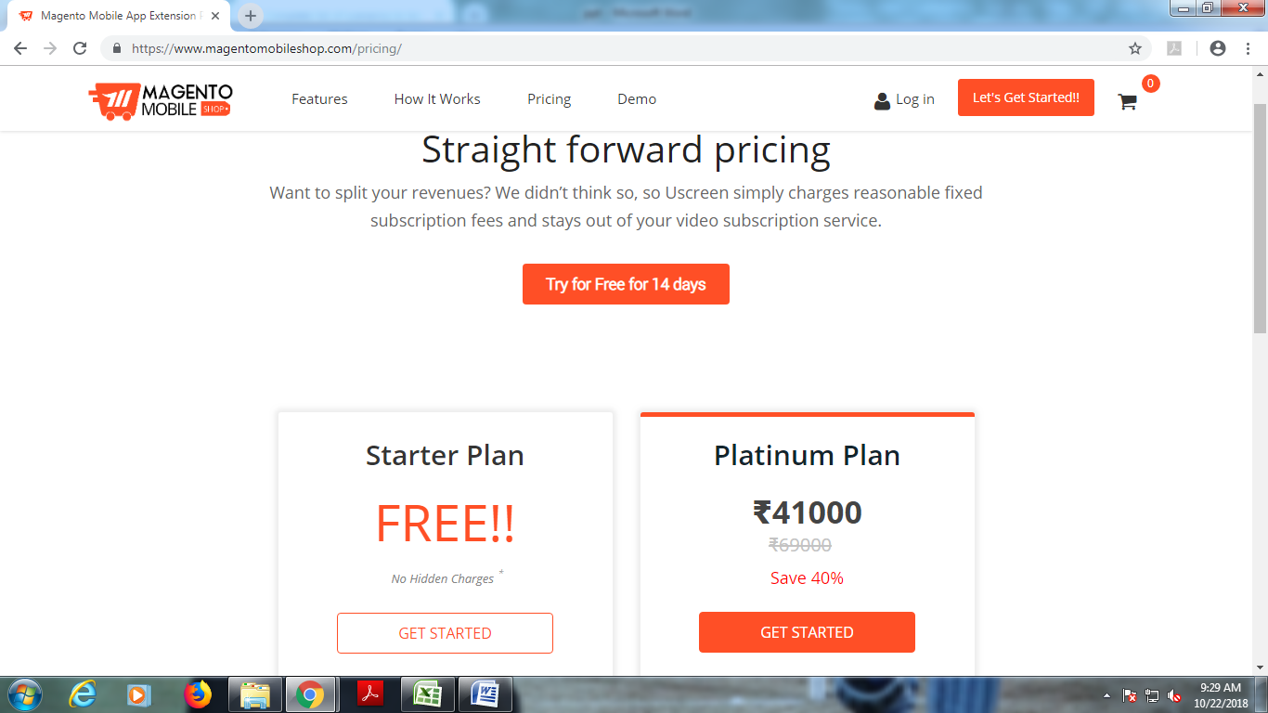

This page gives information about the plans and facilities available in the plans.

* It has free trial for 14 days.
* After 14 days user has to choose from the two plans(Starter Plan) or (Platinum Plan).

**Demo Page**

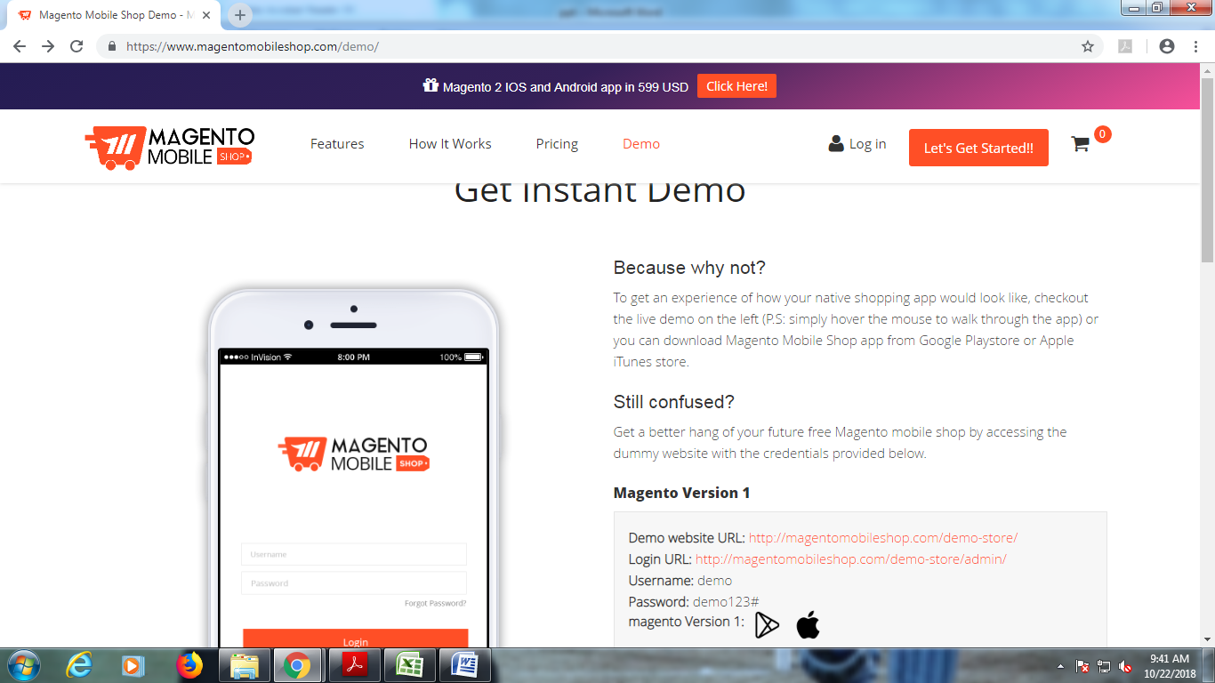

* This page helps the user to get a short demo about how the website works.
* It also helps user to get an idea how to Register/Login to the page.

**Let's Get Started!! Page**

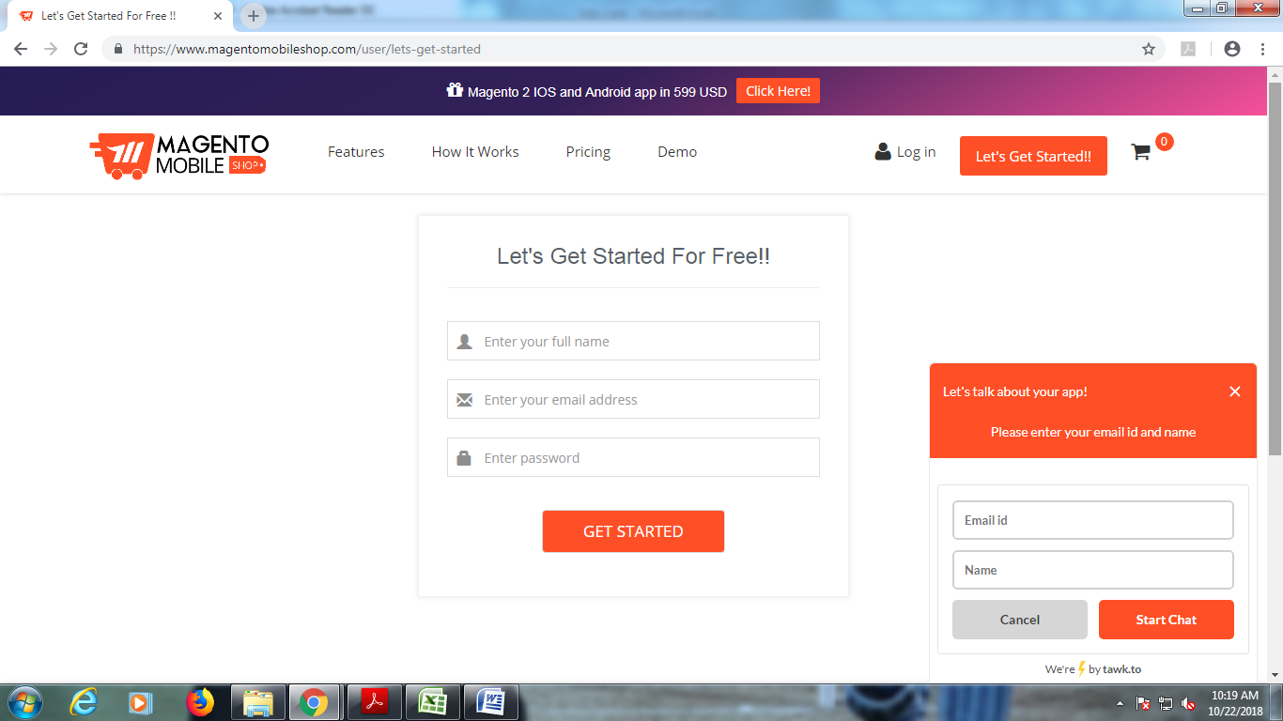

* This page helps the new user to sign up for free.
* After the first time of signup process user will have the credentials to login afterwards.

**Login** **Page**

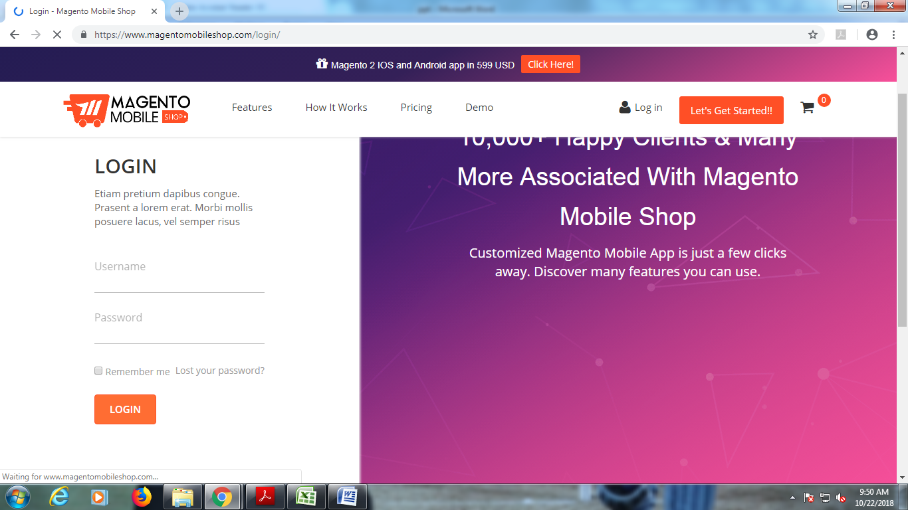

* This page helps the user to login to the page with the valid username and password.
* It has also a facility to recover the password if user has forgot the password.

**Defects Of the page:**

* The page loads too slow.
* Some tabs inside the page are also non-functional.
* Let's Get Started!! tab sometimes throws an error when clicked.
* All the hyperlinks present inside are also too slow to load.
* Some of the times hyperlinks gives an error as shown below.

